Supplementary Information for

Controlling Molecular Orbital Gating in Molecular Junctions by One CH2 Group

*Ziyu Zhang1, Christian A. Nijhuis1,2\**

1 Department of Chemistry, National University of Singapore, 3 Science Drive 3, Singapore 117543, Singapore

2 Centre for Advanced 2D Materials and Graphene Research Centre, National University of Singapore, 2 Science Drive 3, Singapore 117542, Singapore

*Author to whom correspondence should be addressed: chmnca@nus.edu.sg

**S1. Materials and methods**

To be added later.

**S2. SAM preparation**

**S3. Cyclic Voltammetry**

Table S1. Summary of electrochemical characteristics for SAMs on Au surface.

|  |  |  |  |  |  |  |  |  |
| --- | --- | --- | --- | --- | --- | --- | --- | --- |
| SAMs  (on AuTS) | Γ(10-10 mol/cm2) | Epa  (mV) | Epc  (mV) | ΔE  (mV) | Ipa/Ipc | FWHM-Epa(mV) | FWHM-Epc(mV) | EHOMO(eV) |
| OPE1 | 3.47 ± 0.13 | 452 ± 10 | 398 ± 9 | 29 ± 1 | 0.87 ± 0.01 | 140 ± 5 | 115 ± 1 | -5.122 ± 0.006 |
| OPE2 | 3.86 ± 0.08 | 461 ± 9 | 414 ± 10 | 55 ± 2 | 0.80 ± 0.01 | 123 ± 1 | 111 ± 1 | -5.134 ± 0.007 |
| OPE3 | 3.40 ± 0.11 | 484 ± 6 | 445 ± 10 | 53 ± 4 | 0.83 ± 0.04 | 137 ± 2 | 116 ± 3 | -5.161 ± 0.006 |
| OPE1C | 3.59 ± 0.21 | 421 ± 6 | 393 ± 6 | 29 ± 2 | 0.85 ± 0.05 | 218 ± 10 | 186 ± 5 | -5.104 ± 0.006 |
| OPE2C | 3.41 ± 0.14 | 499 ± 5 | 444 ± 3 | 55 ± 2 | 0.71 ± 0.01 | 207 ± 6 | 167 ± 5 | -5.169 ± 0.004 |
| OPE3C | 3.65 ± 0.12 | 504 ± 5 | 451 ± 11 | 53 ± 7 | 0.68 ± 0.01 | 217 ± 14 | 148 ± 6 | -5.174 ± 0.008 |

**S4. X-Ray Photoemission Spectroscopy (XPS)**

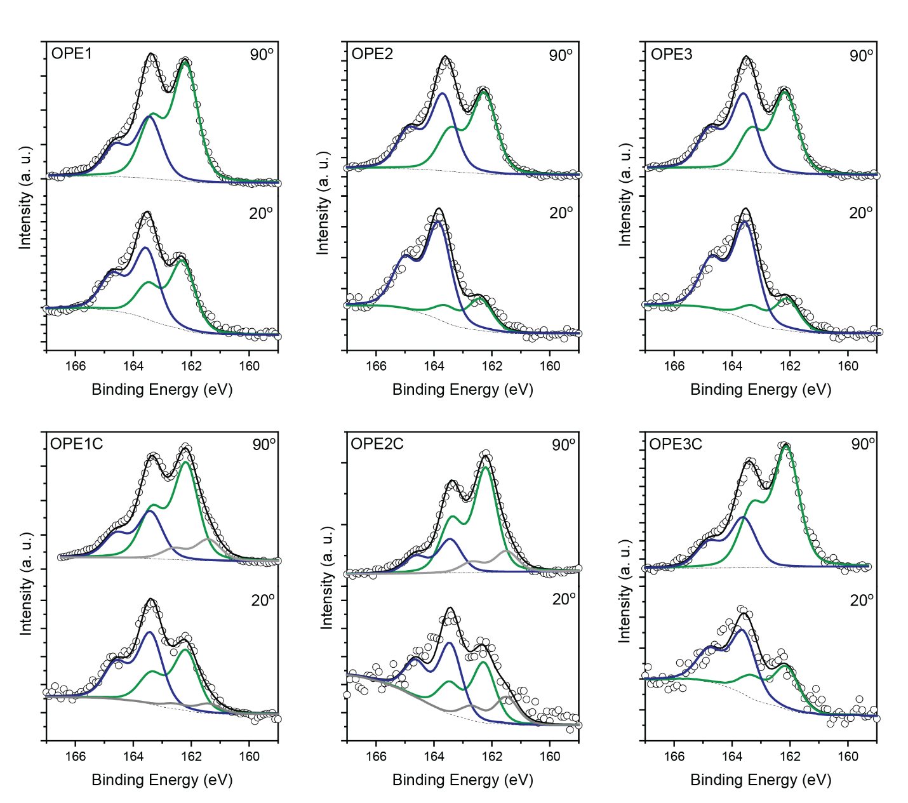

Figure S1. The S 2p XPS of Fc-(OPE)n-SH (OPEn) and Fc-(OPE)n-CH2-SH (OPEnC) on AuTS.

* In all spectra, S1(~162.1 eV, chemisorbed thiolate) and S2 (~163.5 eV, physisorbed thiol) are present. The extra CH2 groups increase the percentage of S1, indicating they help the formation of the chemical bonds. We believe these conjugation breaking units reduce the interaction between the aromatic rings and the metal surface. As a result, the intermolecular interactions are more favoured in the SAM growth phase.
* In the OPE1C and OPE2C molecules, an additional sulphur peak S0 (~161.5 eV) was observed. This peak has been assigned as either atomic sulphur or chemisorbed sulphur in a disordered phase. Here we favour the latter explanation because: 1. There are no proven mechanisms in metal-thiolate bonding that involve the formation of atomic sulphur; 2. The position of S0 sulphur is deep inside the SAM layers, similar to S1, indicating these sulphur atoms are closely bonded to the metal surface.
* The thickness and relative surface coverage are summarised in Table 2.

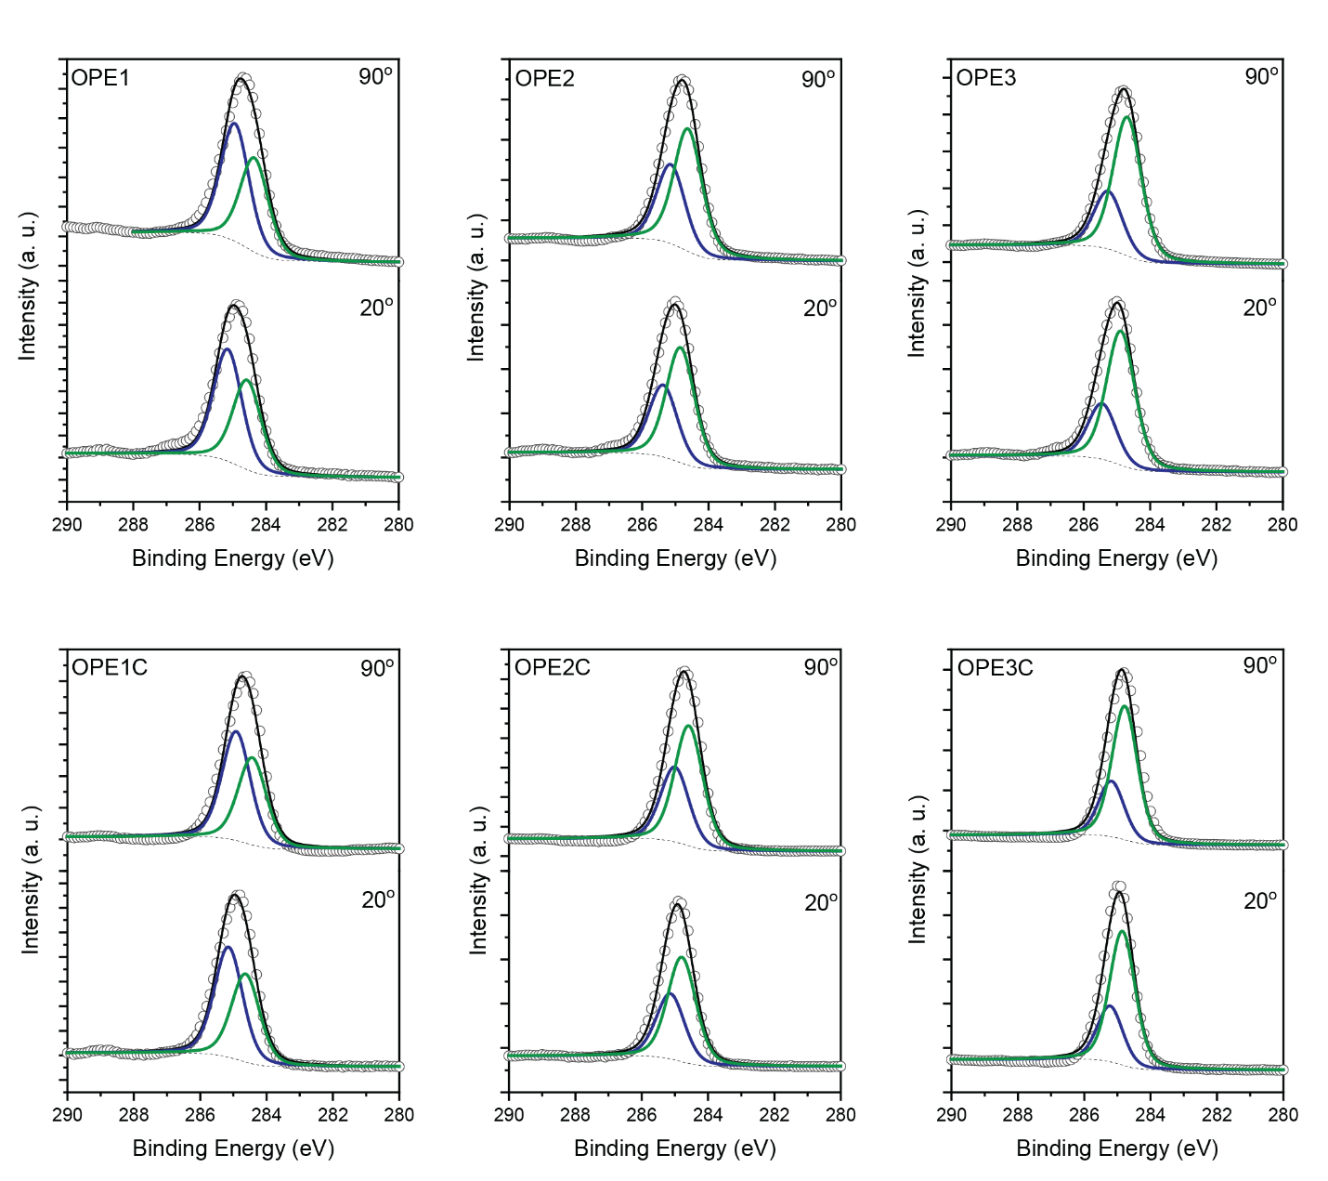

Figure S2. The C 1s XPS of Fc-(OPE)n-SH (OPEn) and Fc-(OPE)n-CH2-SH (OPEnC) on AuTS.

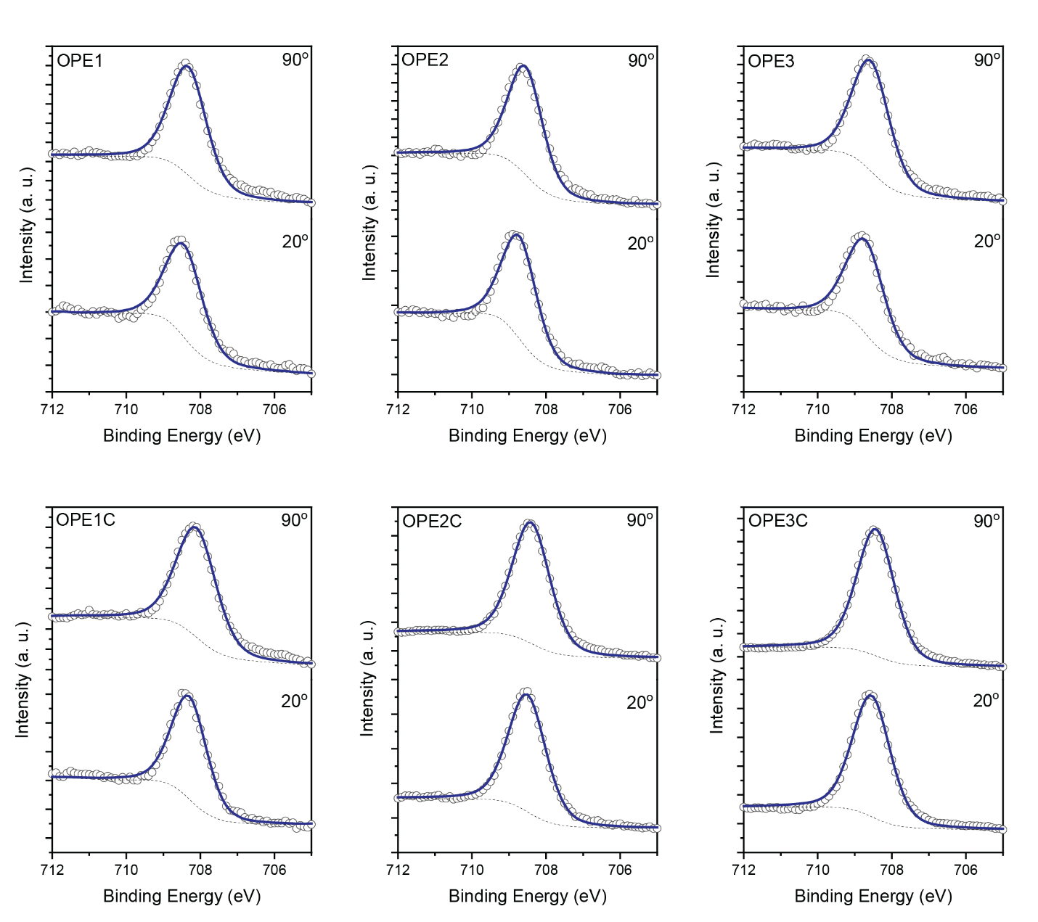

Figure S2. The Fe 2p XPS of Fc-(OPE)n-SH (OPEn) and Fc-(OPE)n-CH2-SH (OPEnC) on AuTS.

**S4. Near-edge X-ray Absorption Fine Structure (NEXAFS)**

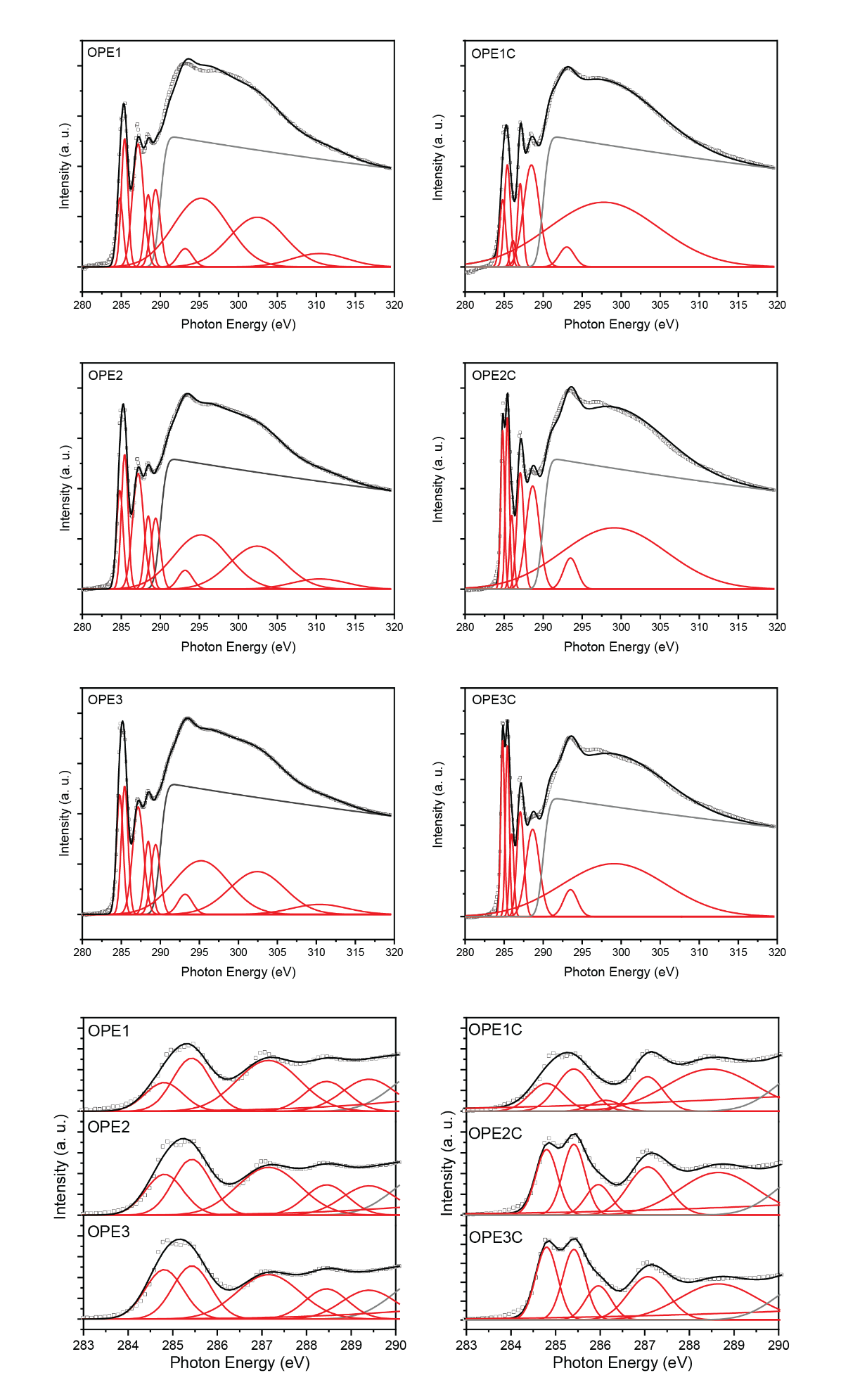

Figure S3. The C K-edge NEXAFS of OPEn and OPEnC on AuTS.

* With the help of PDOS calculation, the first peak at 284.8 eV was assigned to mainly consists of the π* of the aromatic OPE backbone. The second peak at 285.5 eV consist of Fe 3d orbital hybridized with the π* of the cyclopentadiene. The relative intensity of the first two peaks agrees well with this assignment.
* OPE and Cp rings are on the same plane for these molecules, allowing the π orbitals of these two parts have efficient conjugation.
* The OPEnC SAMs again have better packing because of the freedom introduced by the CH2 units. Their smaller tilt angle indicate they are more “standing up”.

**S5. Ultraviolet Photoemission Spectroscopy (UPS)**

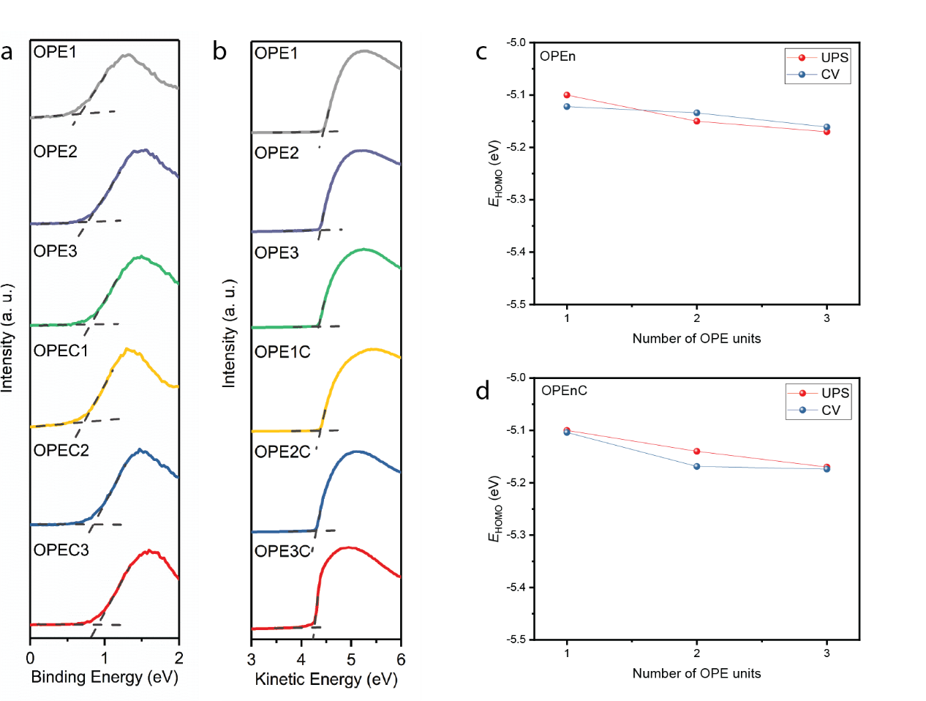

Figure S5. The HOMO level determined by UPS and CV.

* The HOMO level determined by UPS and CV agrees well with each other.

Table S2. The summary of SAM properties determined by UPS, NEXAFS, UV-Vis and XPS.

|  |  |  |  |  |  |  |  |  |  |
| --- | --- | --- | --- | --- | --- | --- | --- | --- | --- |
|  | UPS | | | NEXAFS | | UV-Vis | | XPS | |
| SAM | *Φ*SAM(eV) | *δE*HOMO(eV) | *E*HOMO(eV) | α(º) | *E*g(eV) | | *E*LUMO(eV) | *d*SAM(Å) | relative *Γ* |
| OPE1 | 4.44 | 0.66 | -5.10 | 34 | 3.13 | | -1.97 | 12.5 | 1.1 |
| OPE2 | 4.38 | 0.77 | -5.15 | 33 | 3.05 | | -2.10 | 16.8 | 1.3 |
| OPE3 | 4.35 | 0.82 | -5.17 | 35 | 3.01 | | -2.16 | 22.8 | 1.2 |
| OPE1C | 4.38 | 0.72 | -5.10 | 30 | 3.16 | | -1.94 | 14.7 | 1.1 |
| OPE2C | 4.29 | 0.85 | -5.14 | 25 | 3.03 | | -2.11 | 21.6 | 1.0 |
| OPE3C | 4.26 | 0.91 | -5.17 | 26 | 2.99 | | -2.18 | 24.4 | 1.1 |

**S6. UV-Visible Absorption Spectroscopy**



Figure S6. The UV-Vis spectrum for 0.1M OPEn and OPEnC solutions in THF.

* The optical HOMO-LUMO gap is acquired from the onset of the absorption peak with the highest wavelength. This energy gap is used to determine the LUMO level in the energy level diagram in Figure 5.

**S7. Heatmaps for the *J-V* measurements**

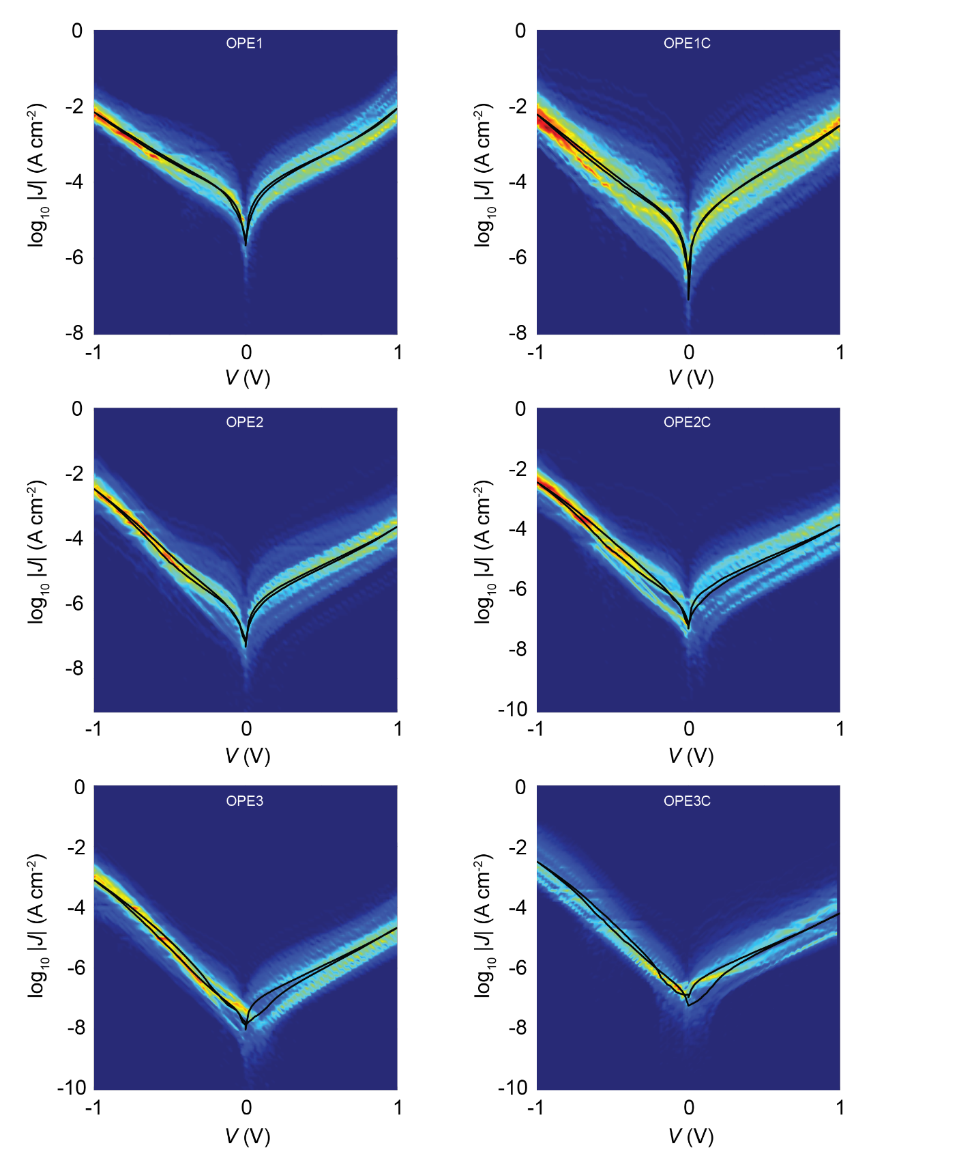

Figure S7. The current density heatmaps of the junctions OPEn//EGaIn and OPEnC//EGaIn.

Table 3. Junction yields for the measurements conducted with cone-shaped EGaIn tips.

|  |  |  |  |
| --- | --- | --- | --- |
| SAMs | No. of junctions | No. of shorts | Non-shorting junctions Yield (%) |
| OPE1 | 20 | 3 | 87 |
| OPE2 | 20 | 3 | 87 |
| OPE3 | 23 | 3 | 88 |
| OPE1C | 23 | 5 | 82 |
| OPE2C | 23 | 6 | 79 |
| OPE3C | 20 | 1 | 95 |

**S8. Temperature-dependent measurement**

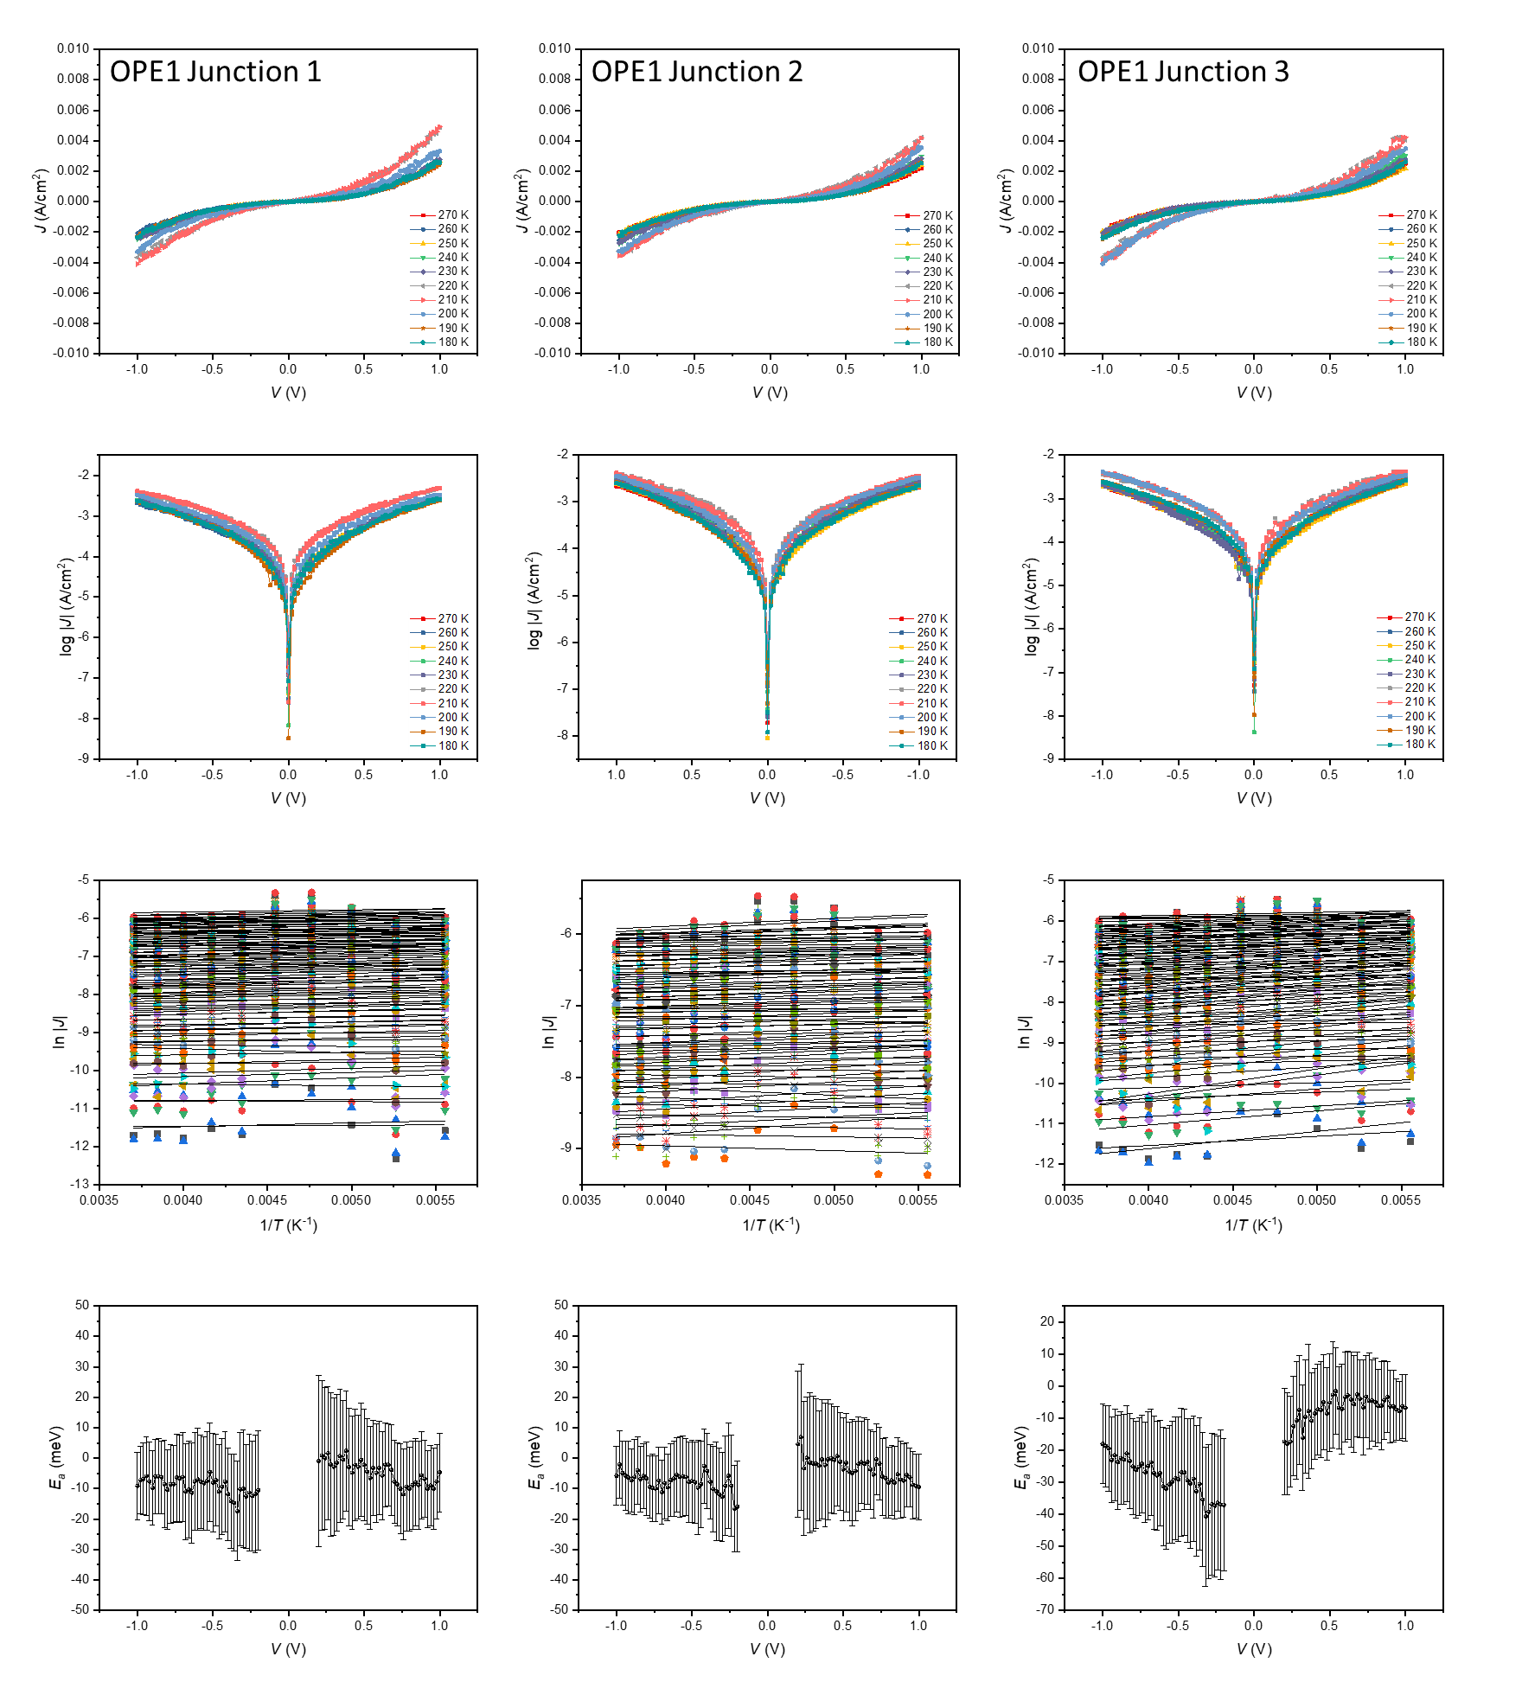

Figure S8. The temperature-dependent J-V measurement for OPE1.

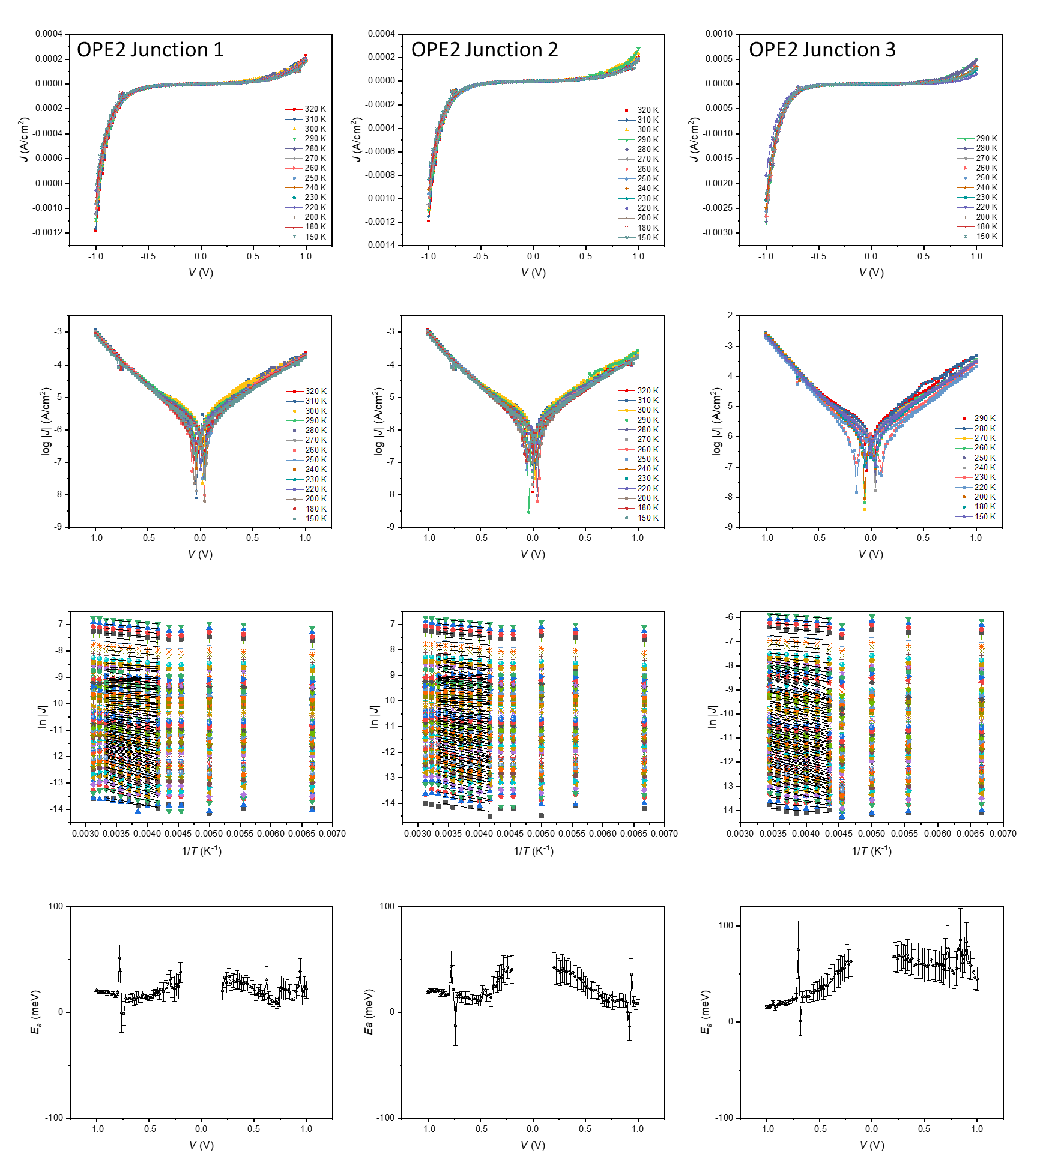

Figure S9. The temperature-dependent J-V measurement for OPE2.

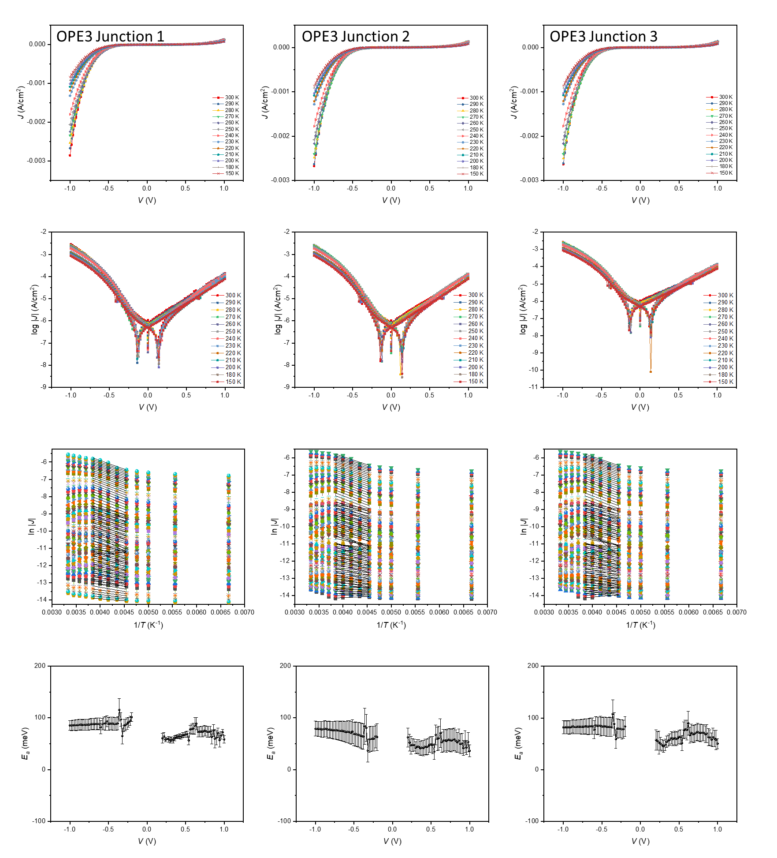

Figure S10. The temperature-dependent J-V measurement for OPE3.

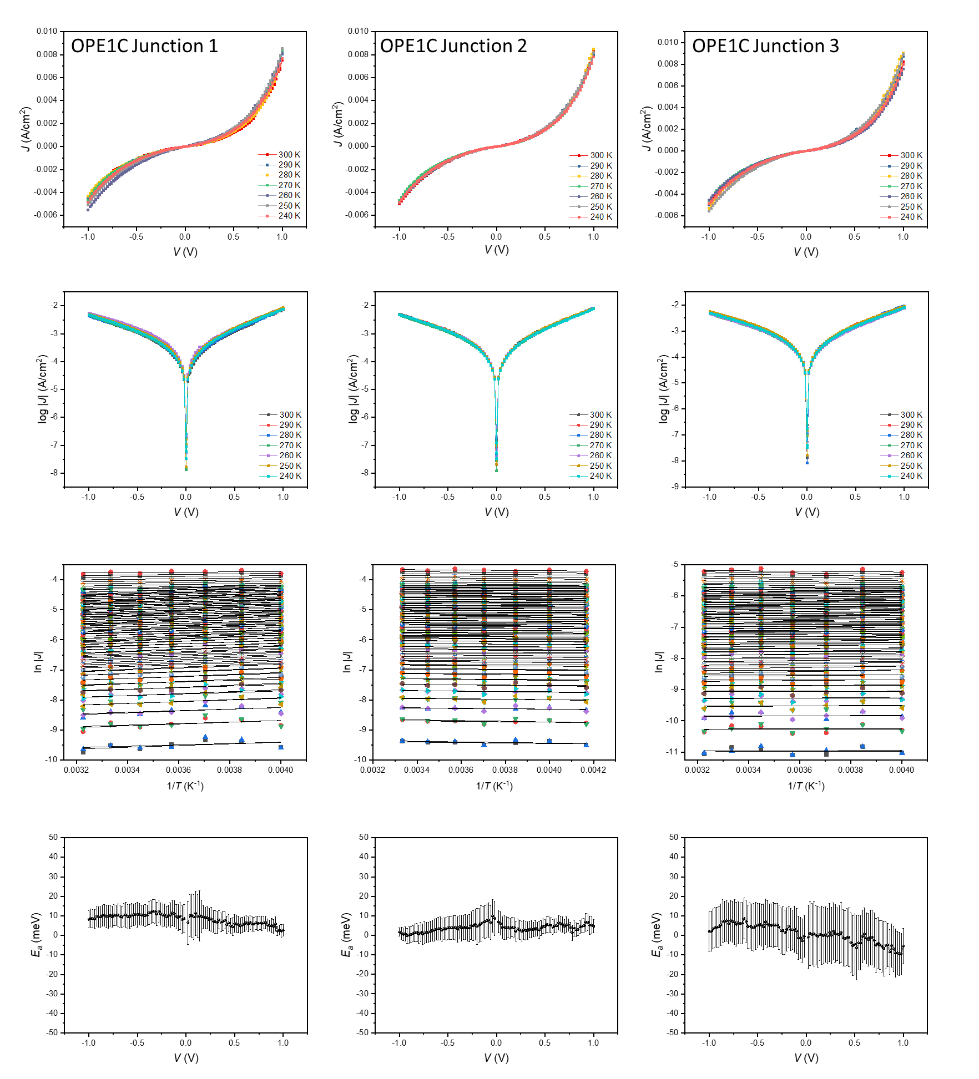

Figure S11. The temperature-dependent J-V measurement for OPE1C.

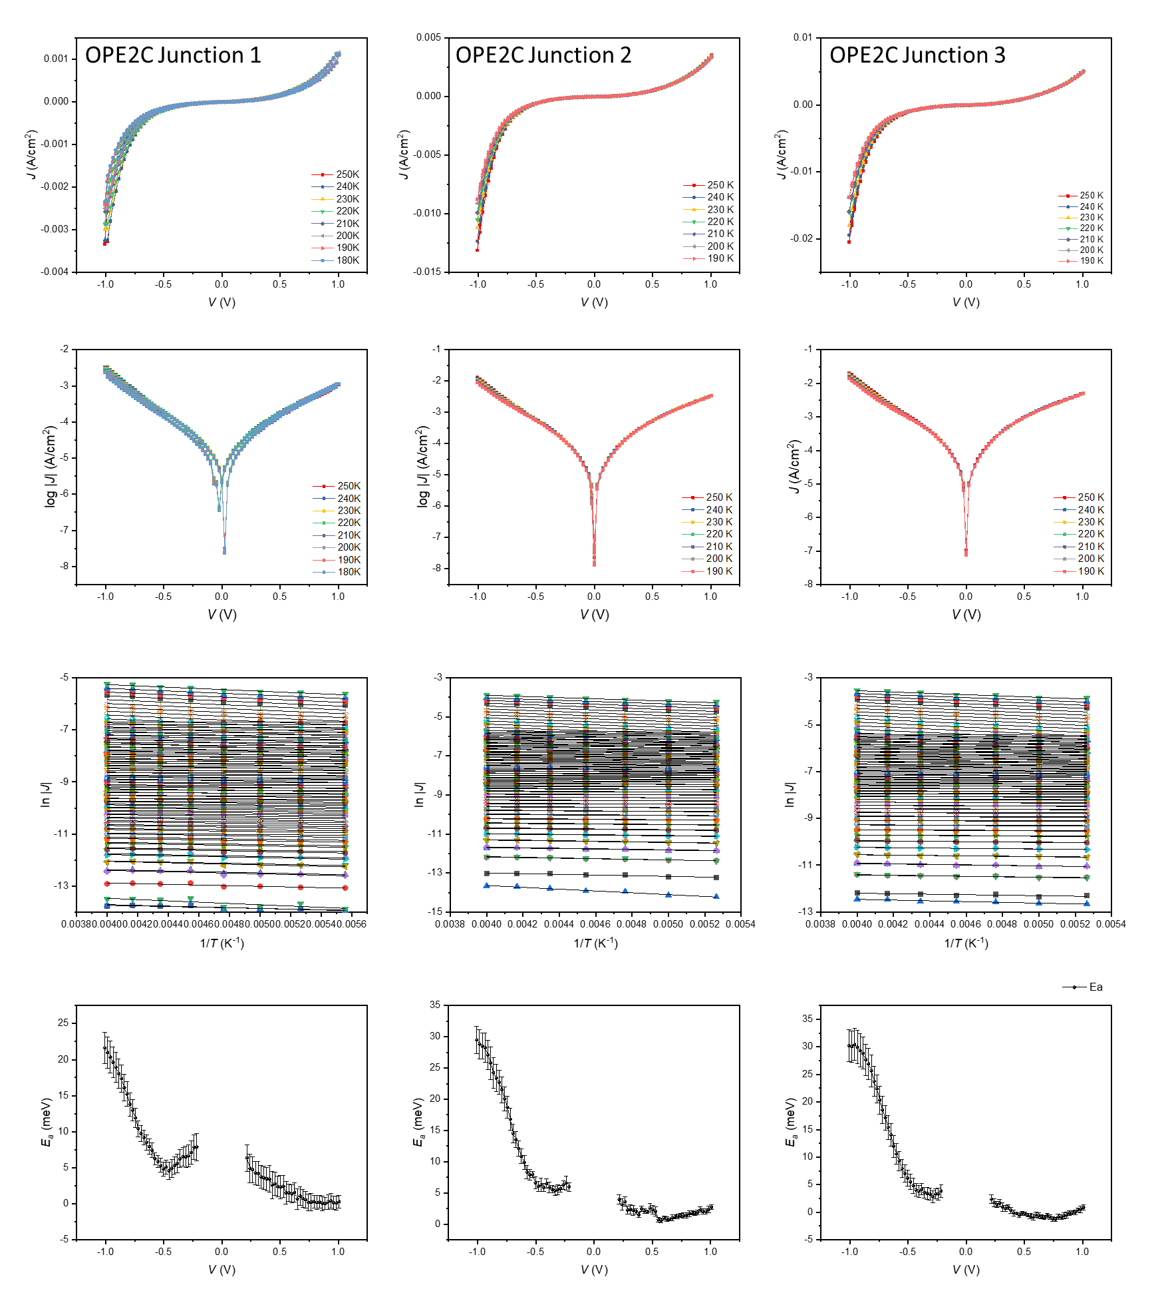

Figure S12. The temperature-dependent J-V measurement for OPE2C.

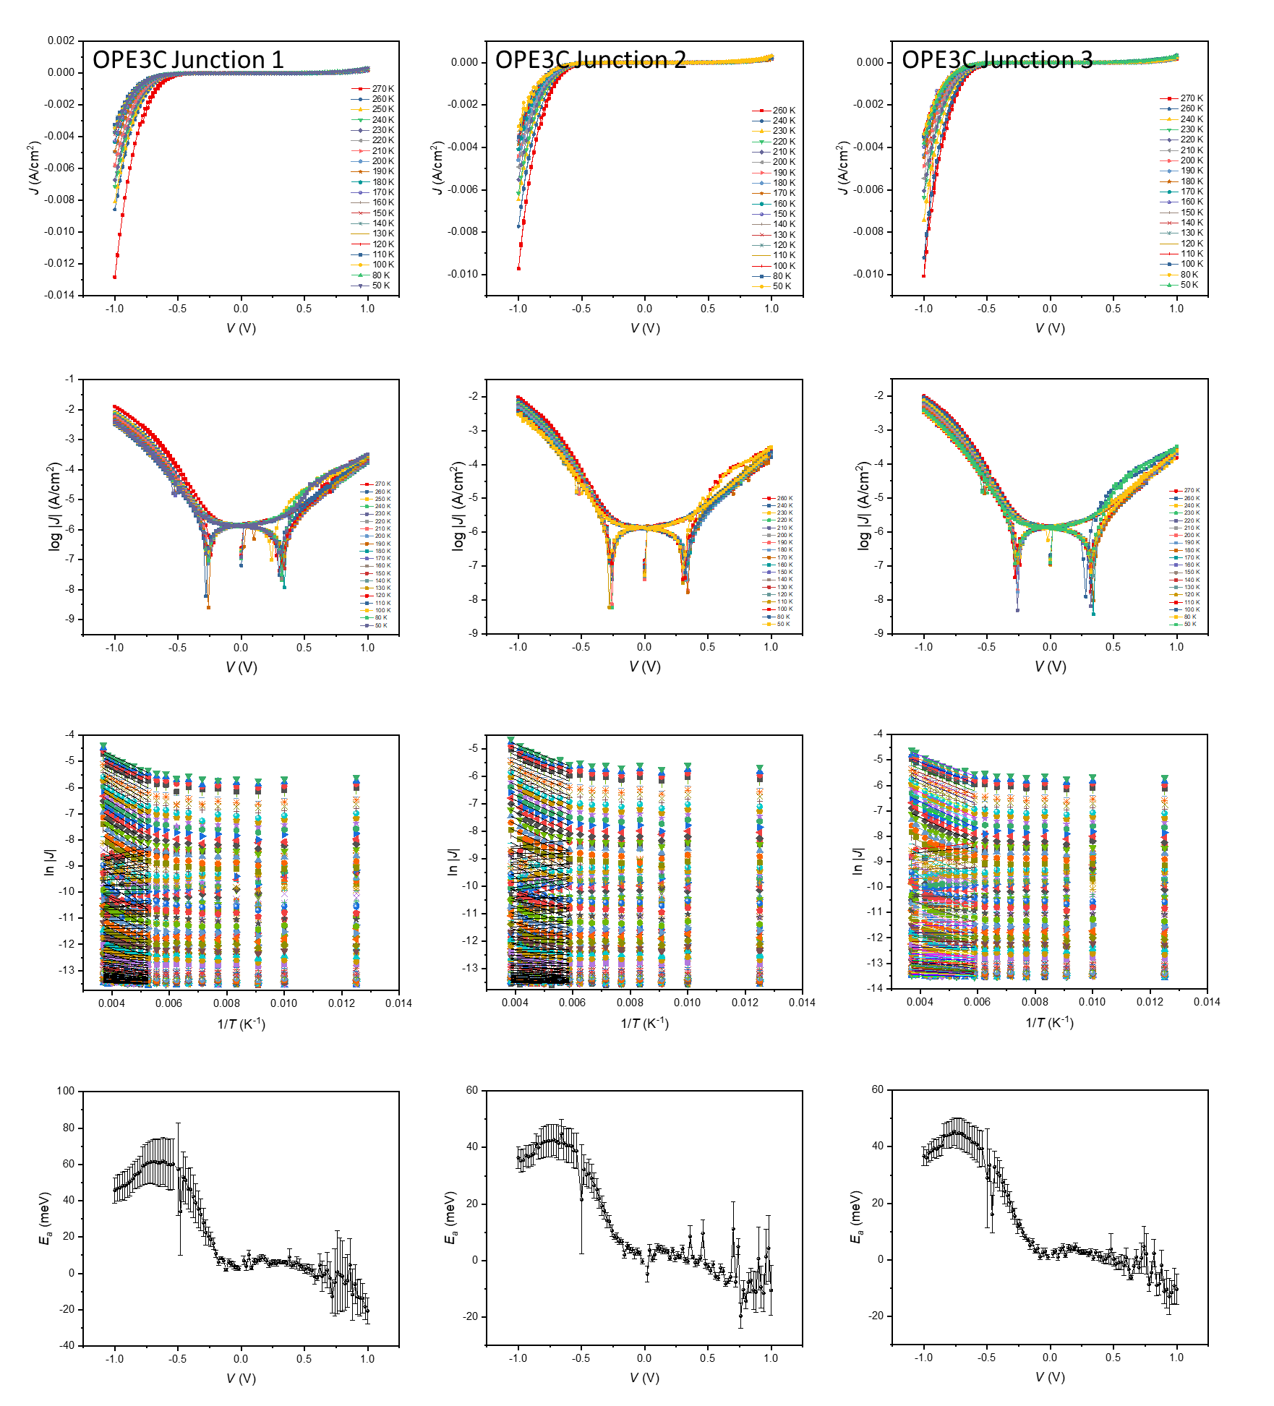

Figure S13. The temperature-dependent J-V measurement for OPE3C.

**S9. Normalized differential conductance (NDC) analysis**



(a)

(b)

(c)

Figure S9. The normalized differential conductance (NDC) plot of junctions (a) OPE1C, (b) OPE2C and (c) OPE3C.

* Figure S9 shows for OPE1C, the NDC plot indicates off-resonant tunnelling. For OPE2C and OPE3C, the NDC shows a clear peak at negative bias, which is a characteristic diode behaviour. The peak position ( -1.1 V for OPE2C and -0.7 V for OPE3C) correlate with the peak in the *Ea*-*V* plot in Figure 4 (d). This confirms that the HOMO of OPE3C molecule enters the conduction window at a lower bias than the shorter molecules.
* As opposed to the current density and activation energy, the NDC plots do not show any obvious dependency to the temperature. NDC reveals the fine structures regarding the shape of the J-V curve. So we can conclude the charge transport mechanism does not vary in the temperature ranged measured this study.